# **Project Report**

1. **Indroduction**



* 1. **Purpose**

**House price prediction in a metropolitan city in India is a valuable solution for potential home buyers, real estate agents, and investors. By leveraging historical sales data, property details, and location-specific information, a predictive model can accurately estimate house price.**

1. **Problem Definition & Design Thinking**

**2.1. Empathy Map**

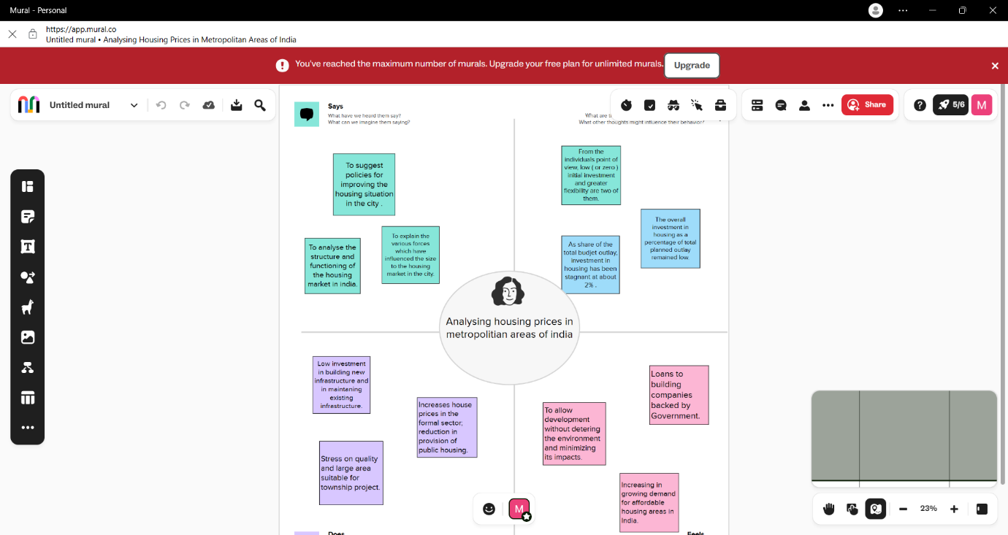

* 1. **Ideation & Brainstorming Map**

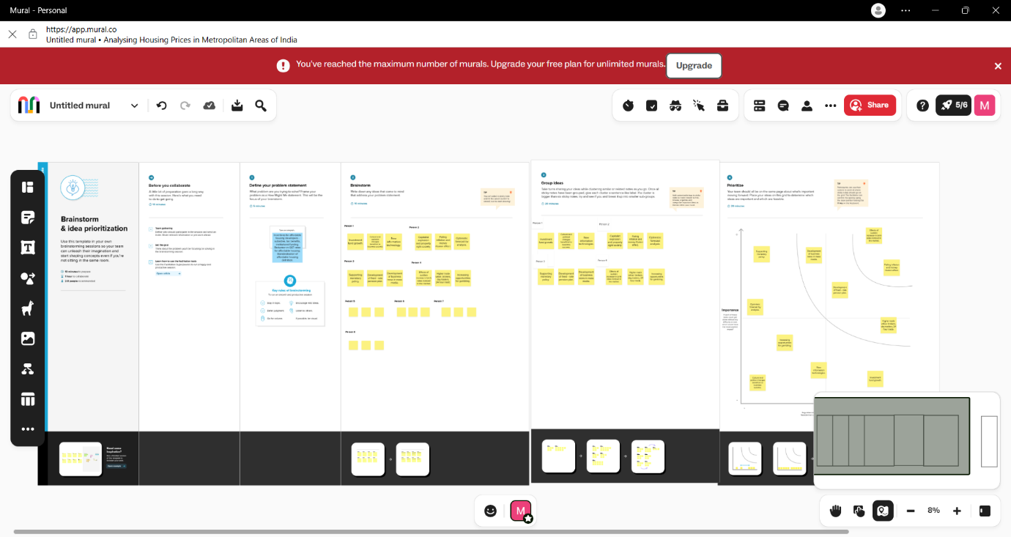

1. **Result**

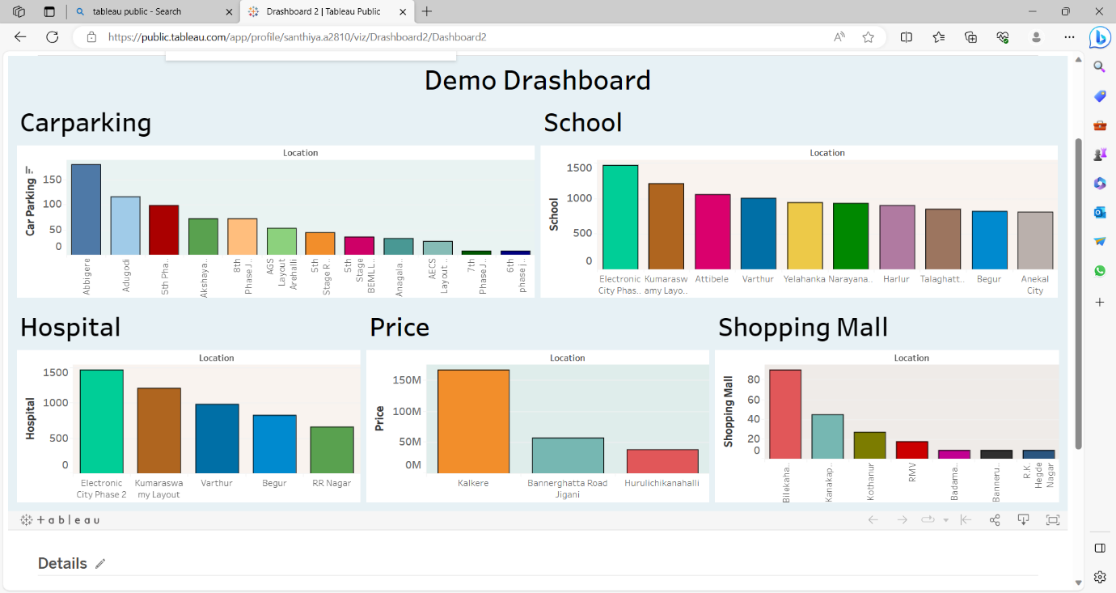

1. **Advantages & Disadvantages**
2. **Investment funds growth.**
3. **New information technology.**
4. **Development of business news in mass media.**
5. **Failing inflation money and illution effect.**
6. **Increasing opportunities of gambling.**
7. **Effect of sudden increase rates of noticed.**
8. **Applications**

**TableauDesktop 2023.2**

1. **Conclusion**

